SDB FURNITURE
REQUIREMENT STATEMENT

MIU-CS425
BIRHAN REDA

- What the System will do

-Allow users and admin to register and log in securely.
-Enable customers to browse furniture products and view details.
-Let customers add items to a shopping cart and place orders.
-Allow admin users to create/add, edit, delete and view products.
-Store all data (users, products, orders) in an SQL database.
-Run as a full-stack application with frontend (React), backend (Spring Boot), and database (SQL)in Docker containers.

- Users of the System

2.1 Customer
. Browse furniture products
. View product details
. Add items to a shopping cart
. Create accounts and log in
. place orders
2.2 Administrator
. Log in with admin privileges
. Add new furniture products
. Edit or update product details
. Delete products from the catalog
. View orders

- System Goal

1. Provide an online shopping platform for browsing and purchasing furniture.
2.Repalce the need for physical furniture showrooms and support 24/7 accessibility
3. Deliver a full-stack application using React, Spring Boot, and SQL.
4.Ensure secure authentication and reliable data storage.
5.Provide admin tools for product management
6.run the entire system consistently using Docker containers.
7.Produce documentation, diagrams, and working code stored in a public GitHub repository.

USE CASE DIAGRAM

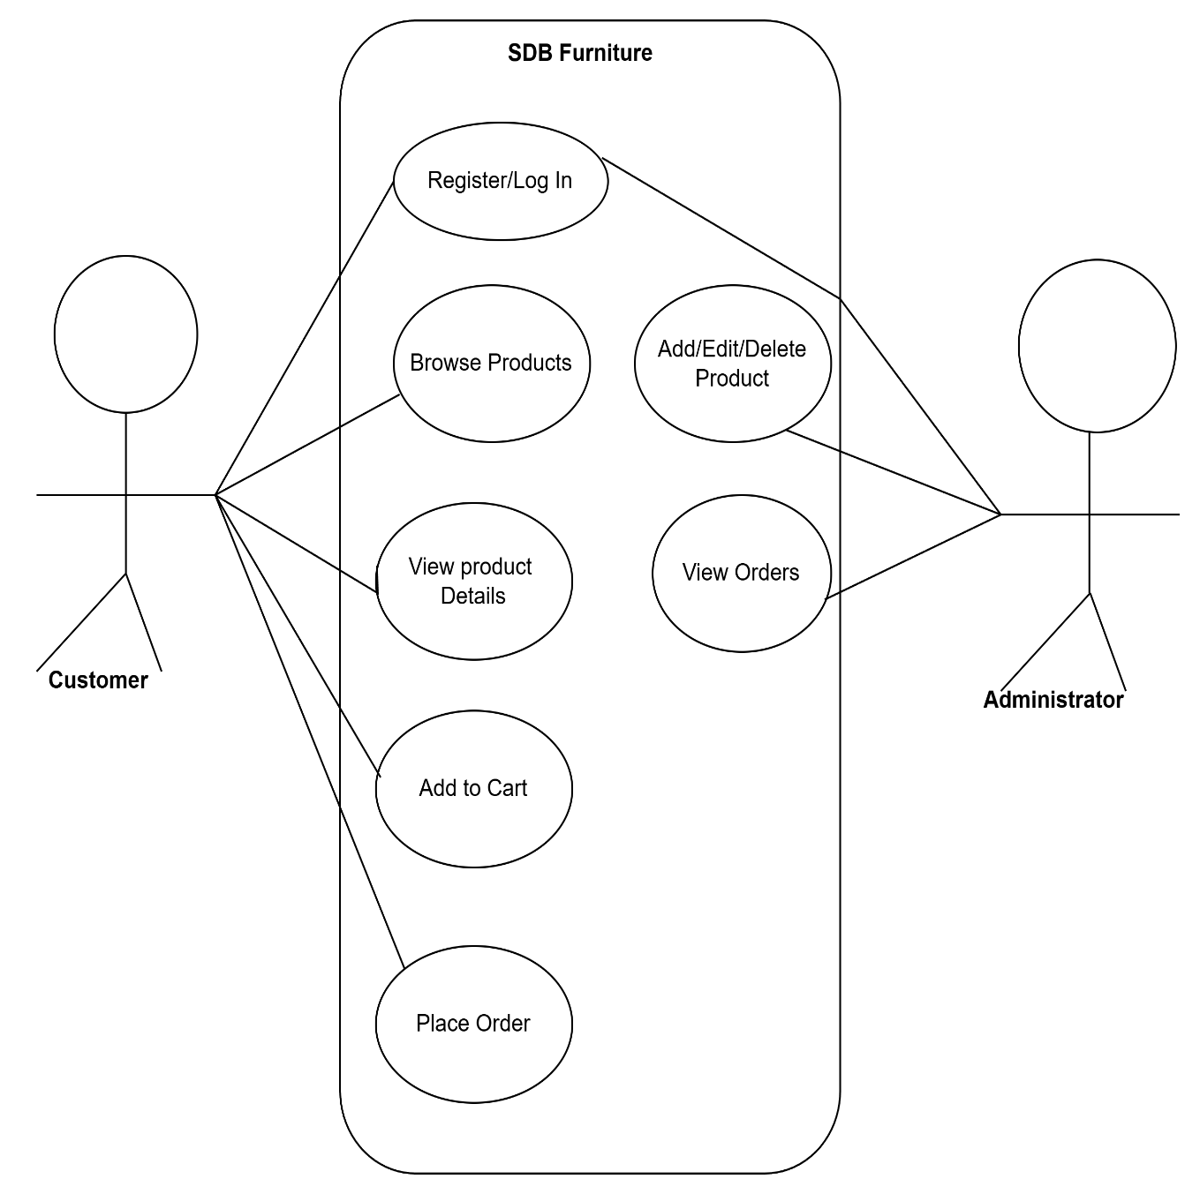

User Stories

user story 1 - Customer Browses Products
As a customer I want to browse and view furniture products so that I can find items I want to buy.
user story 2 -Customer Places an Order
As a customer I want to place an order after adding items to my cart so that I can purchase furniture online.
user story 3 - Admin Manages Products
As an administrator I want to add,edit,and delete furniture products so that I can keep the product catalog updated.

